**Test Set Usage Instructions**

This is a user guide to help the user on creating a scenario using the TestSet_v1.00.xlsm.

1. Open TestSet_v1.00.xlsm.
2. ‘Scenario List’ sheet exists in the document. Here you can enter your scenario names under the ‘Scenario Name’ column. Under the ‘Run (Yes/No)’, enter ‘Yes’ to run the scenario, while entering ‘No’ will skip the scenario.

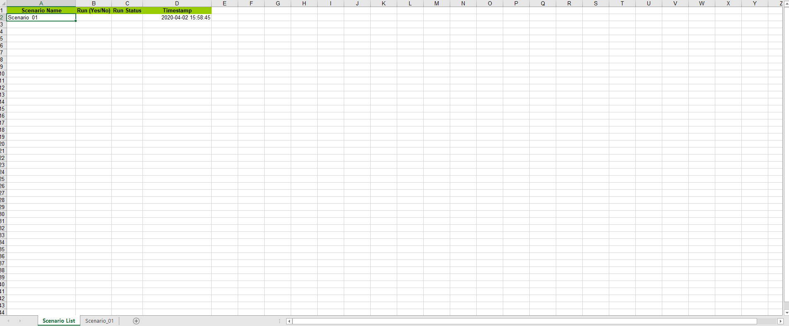

1. Scenario Names should have its corresponding Scenario Sheet. Scenario Name and Scenario Sheet Name is required to have the same name and is case sensitive.
2. Under the ‘Application’ column, select an application under test.

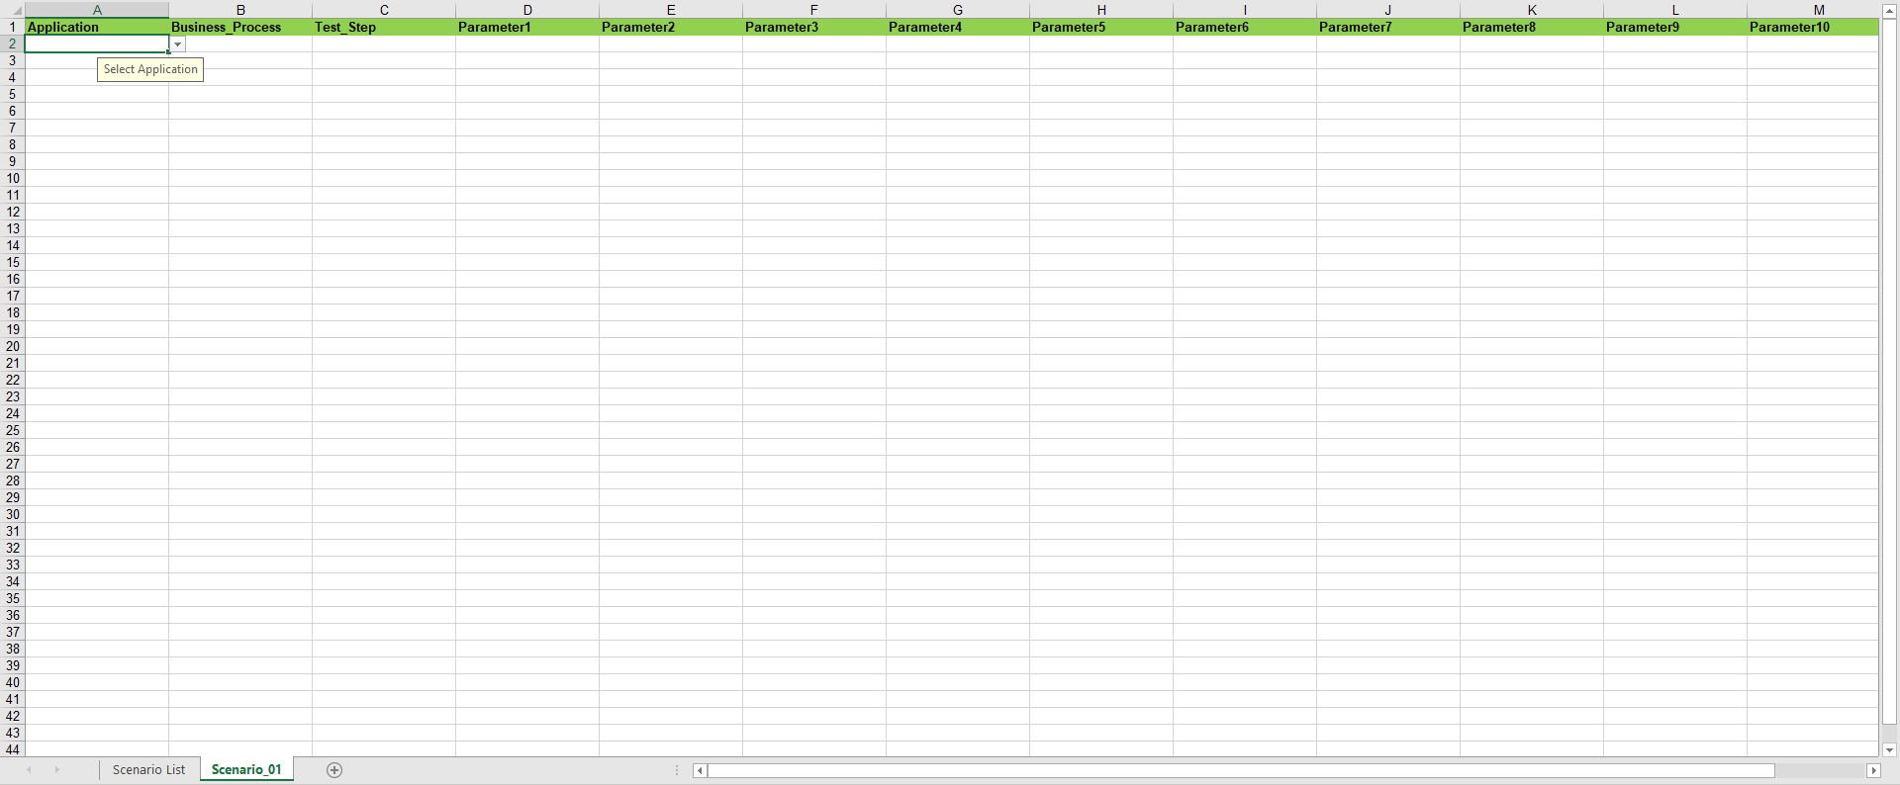

1. After selecting an Application, Business Process dropdown for the selected application will be loaded. Select a Business Process under the ‘Business_Process’ column.

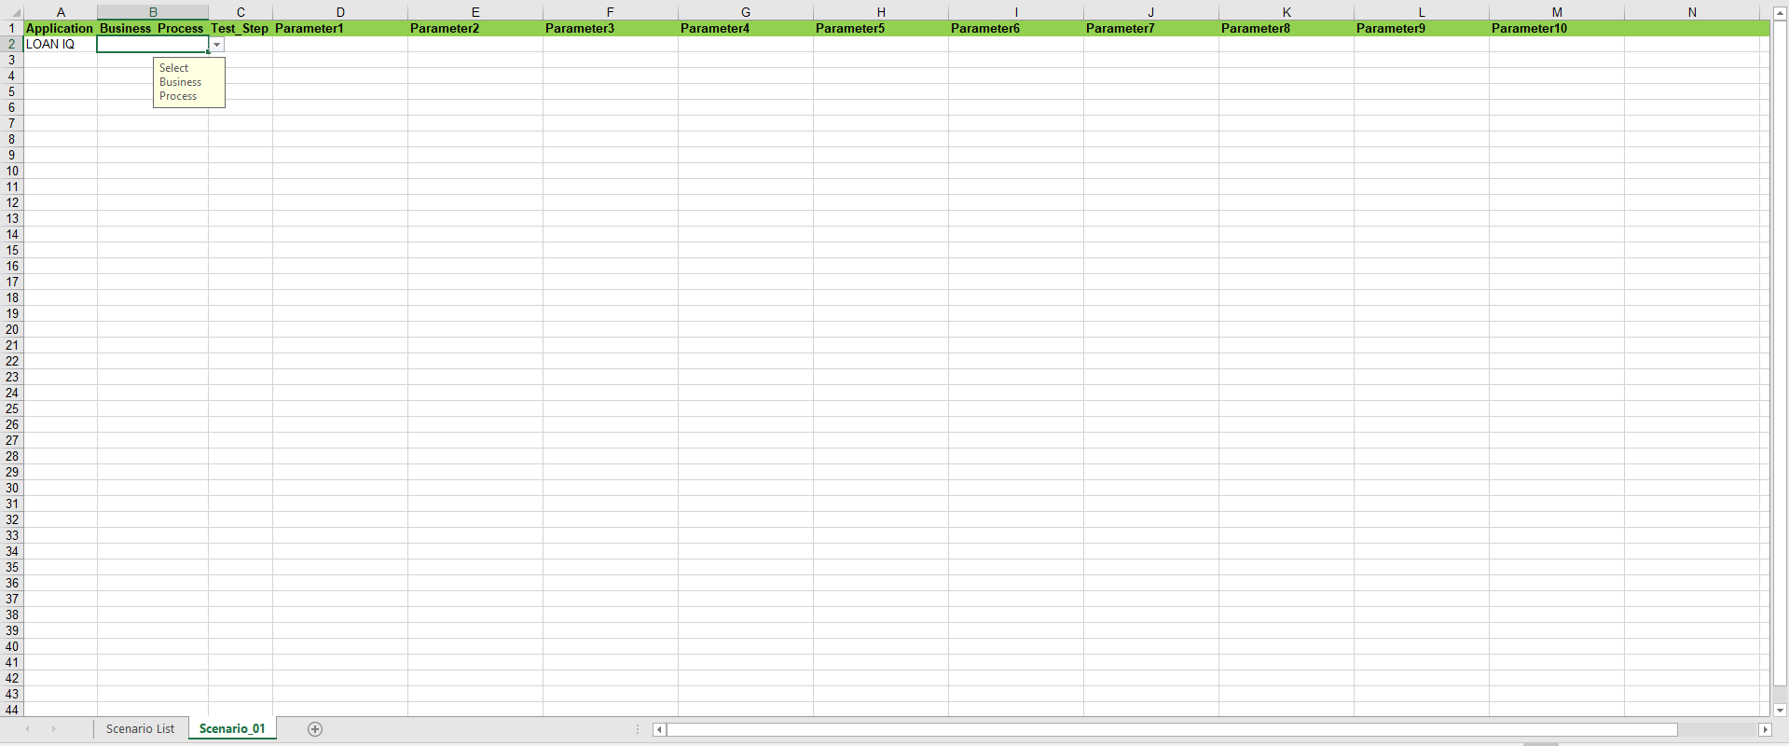

1. After selecting a Business Process, Keywords dropdown for the selected Business Process will be loaded. Select a Keyword under the ‘Test_Step’ column.

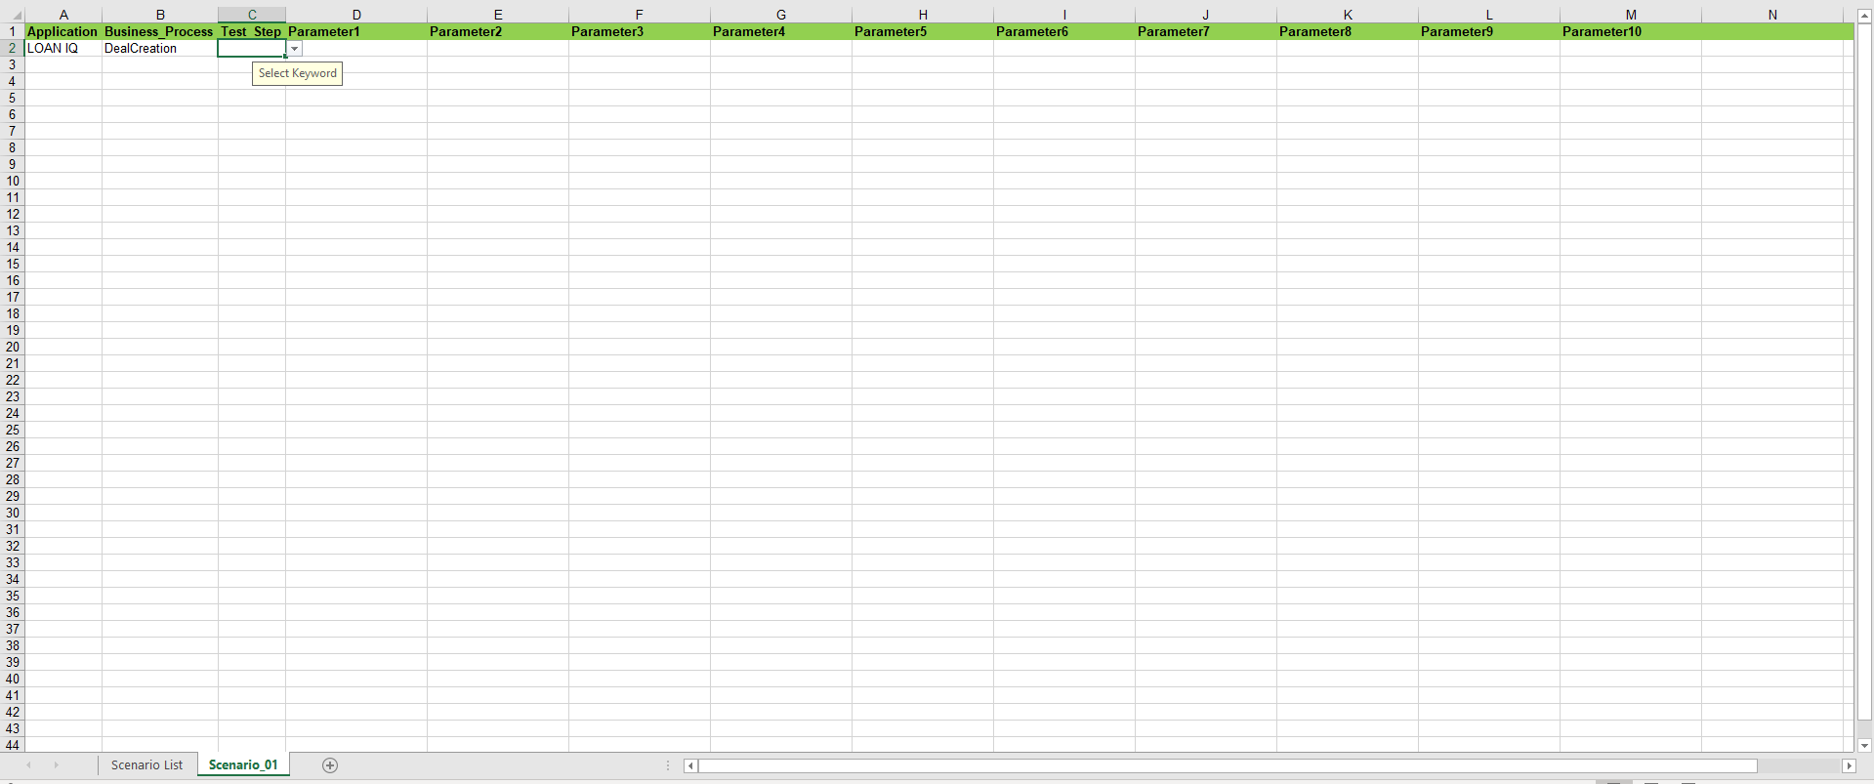

1. After selecting a Keyword for the test step, Keyword parameters will be loaded. Here are the different parameters to fill-out:

* Text Input – This will receive any text entered by the user.



* Dropdown Input – User can only select on the dropdown options provided.

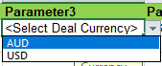

* Text Input w/ Runtime Options – A parameter that accepts user desired value, Runtime Full Value option or a Runtime Value with a desired prefix. Hover to Parameter’s Cell to see the available Input Option Formats.

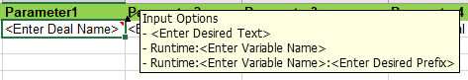

* Text Input w/ Get Runtime Options - A parameter that accepts user desired value or gets a Runtime Value generated from another keyword (or test step). Hover to Parameter’s Cell to see the available Input Option Formats.



1. Fill-out Keyword Parameters with the data needed for the test execution.
2. Repeat Steps 1 to 8 for creating every step on the scenario. Copy & Paste may be used as well.
3. For creating a new scenario, simply add a new sheet and rename it with your desired scenario and register the scenario name at the ‘Scenario List’ sheet.
4. You may delete a Scenario Sheet but ‘Scenario List’ may not be deleted. It is a required sheet for robot drive script to work.